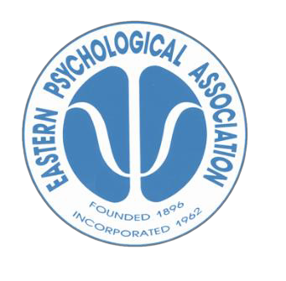Eastern Psychological Association

96th EPA Meeting, March 6th – March 8th, 2025

Marriott Marquis, New York City

Information for Sponsors

# Annual Conference

At the annual EPA conference, senior researchers and their students present their latest research in the form of talks, posters, and symposia. Keynote addresses from eminent psychologists are a highlight of the meeting.

# Attendance and Exhibit Hall Hours

More than 2000 people are expected to attend the 2025 conference in New York. Attendees include academic and professional psychologists, along with graduate and undergraduate students. Exhibit hours will be 8 AM-5 PM on Friday, March 7th and Saturday, March 8th. Exhibitors may set up their booths after 2PM on March 6th and breakdown after 5 PM on March 8th.

**About EPA**

Eastern Psychological Association (EPA), founded in 1896, is the oldest regional Psychological Association in the United States. Its sole purpose is to advance the science and profession of psychology through the dissemination of information about the field of Psychology.

**Sponsorship Opportunities**

**Platinum Sponsor $5000**

* 1 Exhibit Booth
* 6 Complimentary conference registrations
* Full page color ad in the printed program (back cover, if available)
* Flip book ad and link*
* EPA website listing and link
* Mobile app** listing with links and streaming banner
* Broadcast messaging*** thru conference administrator to all meeting attendees
* Tote bag logo and URL
* Keynote session banner
* Video upload to the mobile app

**Gold Sponsor $3500**

* 1 Exhibit booth
* 4 complimentary conference registrations
* Full page B/W printed ad in the printed program
* Flip book ad and link
* EPA website listing and link
* Mobile app listing with links and streaming banner
* Broadcast messaging thru conference administrator to all meeting attendees
* Tote bag logo**** and URL
* Keynote session banner*****

**Silver Sponsor $2500**

* 1 Exhibit booth
* 2 complimentary conference registrations
* One-half page B/W printed ad in the printed program
* Flip book ad and link
* EPA website listing and link
* Mobile app listing with links and streaming banner
* Broadcast messaging thru conference administrator to all meeting attendees

**Bronze Sponsor $1500**

* 1 Exhibit booth
* One-half page B/W printed ad in program book
* Flip book ad and link
* EPA website listing and link

|  |
| --- |
| *The digital flip book will be released 6 weeks before the start of the meeting, providing unrivaled opportunities for sponsors to reach out to all meeting attendees. |
|  |
| ** The mobile app, used by all attendees will list and stream sponsors on the home page. Links are provided on the sponsor's detail page. |
|  |
| *** The EPA administrators will broadcast the sponsor's message to all attendees during the conference. |
|  |
| **** The sponsor's logo and URL will be placed on the popular EPA tote bag |
|  |
| *****A sponsor may place a banner ad to appear at the start and end of a keynote session. |
|  |
| For those who would like to be a sponsor at the silver, gold or platinum level but who can't attend the meeting as an exhibitor, simply subtract $1500 from the aforementioned levels.  For additional sponsorship opportunities (e.g., student travel support, receptions, coffee breaks), contact Dr. Paul Schnur, epaexecofficer@gmail.com |

|  |
| --- |
|  |
|  |
|  |
|  |